

Title: AI | Code: CS- 351 | Total Marks: 10
Instructor: Dr. Khurram Jadoon | Quiz No: 03
Reg#: ________________________ | Name: _______________________________________

Question No 01:
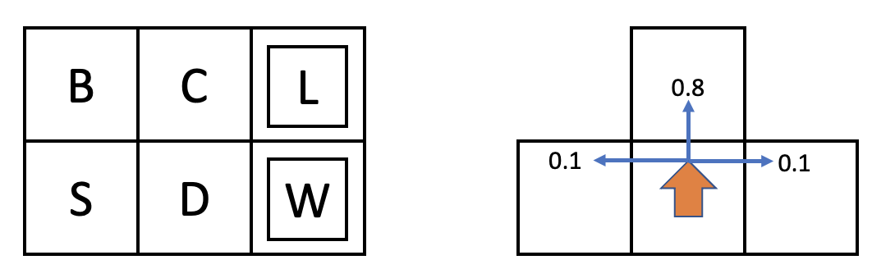
This grid world MDP operates like the one we saw in class. The states are grid squares, identified by letter. The agent always starts in state S. There are two terminal goal states, L(oss) with reward R(L, exit, x) = −5 and transition T(L, exit, x) = 1.0, and W(in) with reward R(W, exit, x) = +5 and transition T(W, exit, x) = 1.0. Rewards R(s) are 0 in non-terminal states. The transition function is such that the intended agent movement (North, South, West, or East) happens with probability .8. With probability .1 each, the agent ends up in one of the states perpendicular to the intended direction (see Figure 1 Right). If a collision with an outer edge happens, the agent stays in the same state.
Figure 1: Left: MDP setup. Start in S. Terminal states L and W.
Figure 1: Right: Transition function. Given an action such as north, 80% of the time it will go north, and 10% each will wind up east or west (perpendicular to the action direction).
Suppose that γ = 0.9. Compute V₀, V₁, and V₂ using value iteration by filling in the table below.
